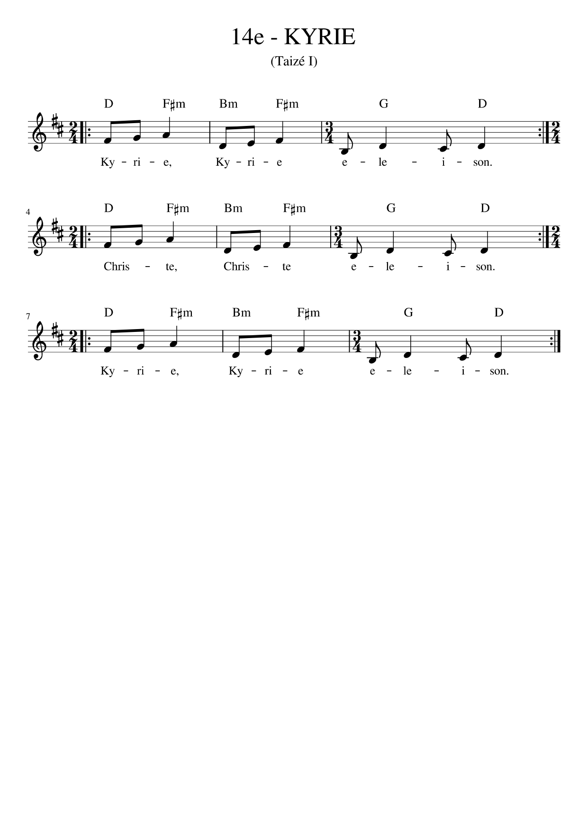

D F#m Bm F#m G D F#m Bm F#m G D
Kyrie, Kyrie eleison! Kyrie, Kyrie eleison!

D F#m Bm F#m G D F#m Bm F#m G D
Christe, Christe eleison! Christe, Christe eleison!

D F#m Bm F#m G D F#m Bm F#m G D
Kyrie, Kyrie eleison! Kyrie, Kyrie eleison!

