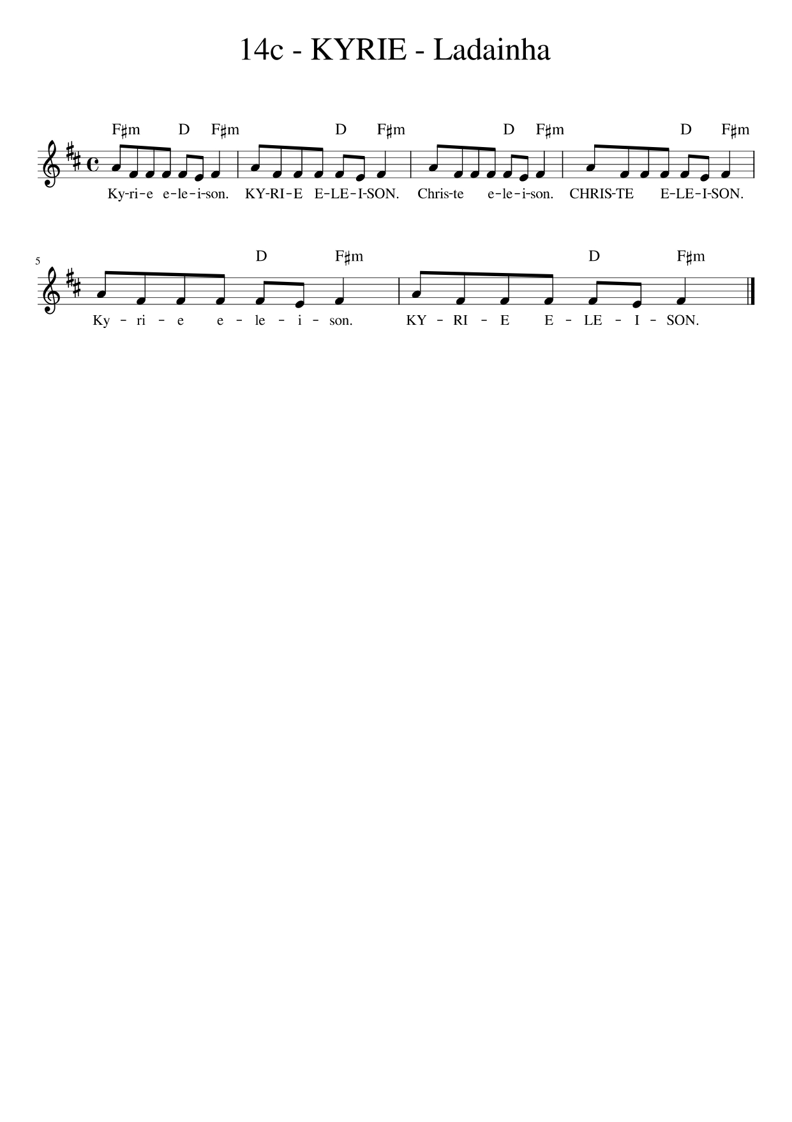

F#m D F#m D F#m
Kyrie, eleison! Kyrie, eleison!

F#m D F#m D F#m
Christe, eleison! Christe, eleison!

F#m D F#m D F#m
Kyrie, eleison! Kyrie, eleison!

